
Saveetha Institute of Medical and Technical Sciences

Smart Waste Classification System
A CAPSTONE PROJECT REPORT
Submitted in partial fulfilment for the Course of
CSA1711 – Artificial Intelligence
towards the award of the degree of BACHELOR OF ENGINEERING
Submitted by
D. Lokesh –192372216
T. Charani Kirthi Sri– 192312550
R. Vishwa Teja -192372109

Under the Supervision of
Dr K. Krishna Kumar

August – 2026

ABSTRACT
Improper segregation of municipal solid waste remains one of the leading causes of low recycling efficiency, landfill overuse, and environmental pollution in growing urban areas. Manual sorting is slow, inconsistent, and exposes sanitation workers to hazardous material. This report presents the design and implementation of a Smart Waste Classification System that uses a camera-based deep learning classifier, supported by auxiliary sensors, to automatically identify waste items as biodegradable, recyclable, or non-recyclable and route them into the correct compartment in real time.
The report defines the project's objectives and breaks them down into five focused sub-questions that guided the design and evaluation of the system. It then presents the system architecture and module-level design, followed by the implementation details, including the source code for the classification pipeline and a description of the image dataset used for training. Representative screenshots of the working implementation are included, along with the resulting conclusions and an evaluation rubric used to assess the project.

TABLE OF CONTENTS
Chapter | Title | Page
1 | Objectives | 3
2 | Five Sub-Questions Related to the Objective | 4
3 | Design Chapter | 5
4 | Implementation (Source Code and Dataset) | 8
5 | Screenshots of Implementation | 12
6 | Conclusion | 14
7 | Evaluation Rubric | 15

CHAPTER 1: OBJECTIVES

The overall aim of this project is to design and implement a Smart Waste Classification System that automatically identifies the category of a waste item and directs it to the correct compartment, reducing dependence on manual sorting and improving recycling accuracy. The specific objectives of the project are as follows:
- To design a camera-based image classification pipeline that categorises waste into biodegradable, recyclable, and non-recyclable classes.
- To combine visual features with low-cost auxiliary sensors (weight, moisture, and metal-proximity) to improve classification reliability in real-world conditions.
- To implement an automated segregation mechanism that routes classified waste into the correct bin compartment using actuator control.
- To build a monitoring dashboard that reports bin fill-levels and classification statistics to support efficient waste-collection scheduling.
- To evaluate the trained classification model on a held-out test dataset and document its accuracy, confusion patterns, and limitations.
- To produce a modular, well-documented implementation that can be extended with additional waste categories or deployed on embedded hardware in future work.

CHAPTER 2: FIVE SUB-QUESTIONS RELATED TO THE OBJECTIVE

To make the primary objective measurable and to guide the design and implementation decisions described in later chapters, the objective was broken down into the following five sub-questions:
Q1. Which classification approach gives the best accuracy-to-speed trade-off for a smart bin?
This question compares a lightweight convolutional neural network (e.g. MobileNetV2) against classical machine-learning classifiers (e.g. Random Forest on hand-crafted features) to determine which approach is best suited to run in near real time on low-power embedded hardware without a large loss in accuracy.
Q2. Which input features most reliably separate the waste categories?
This question investigates how much classification accuracy improves when image data is fused with auxiliary sensor readings such as weight, moisture level, and metal proximity, compared to using image data alone, in order to identify the minimum sensor set needed for reliable classification.
Q3. How does dataset size and class balance affect generalisation?
This question examines how the number of training images per class and the balance between classes affect the model's accuracy on unseen waste items, and what data-augmentation strategies help the model generalise when some categories are under-represented.
Q4. What actuator and mechanical design minimises segregation errors and delay?
This question looks at how the segregation controller should be designed — in terms of actuator type, response time, and compartment layout — so that classified waste is routed correctly with minimal latency and without jamming the mechanism.
Q5. How should classification and bin-status data be communicated to support collection planning?
This question addresses how real-time classification results and bin fill-levels should be transmitted to a central dashboard so that municipal staff can prioritise collection routes and reduce overflow incidents.

CHAPTER 3: DESIGN CHAPTER

3.1 System Architecture
The system follows a modular pipeline in which a waste item is sensed, classified, and physically segregated, while its status is continuously reported to a monitoring dashboard. Figure 1 shows the overall architecture.
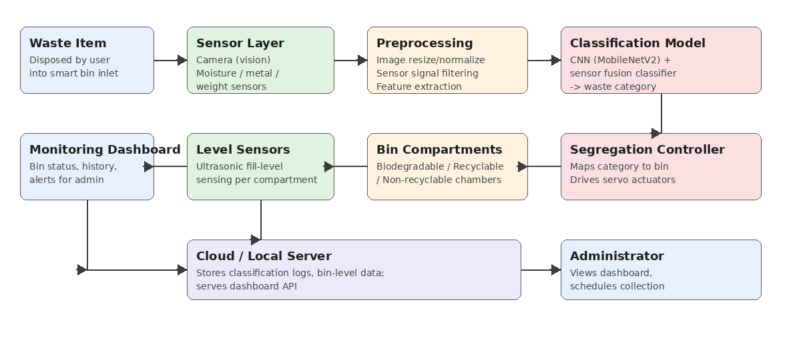
Fig. 1 — Smart Waste Classification System architecture

3.2 Module Description
Module | Description
Sensor Layer | Captures an image of the waste item and reads auxiliary weight, moisture, and metal-proximity sensors.
Preprocessing Module | Resizes/normalises images and filters raw sensor signals before they are passed to the classifier.
Classification Model | A CNN (transfer-learned MobileNetV2) fused with sensor features predicts the waste category.
Segregation Controller | Maps the predicted category to a servo/actuator command that opens the correct compartment.
Bin Compartments | Physical chambers for biodegradable, recyclable, and non-recyclable waste, each fitted with an ultrasonic level sensor.
Monitoring Dashboard | Web-based interface that displays live classification results, bin fill-levels, and historical statistics to the administrator.
Cloud / Local Server | Stores classification logs and bin-level data and exposes an API consumed by the dashboard.

3.3 Class-Level Design
The system is modelled using object-oriented principles. The key classes, their attributes, and their responsibilities are summarised below.
Class | Key Attributes | Key Methods
Waste Item | id, timestamp, image Path, sensor Readings | Capture Image (), read Sensors ()
Classifier Model | Model Path, class Labels, confidence Threshold | Pre-process (), predict(), get Confidence()
Segregation Controller | Compartment Map, actuator State | Route Item(category), open Compartment(id)
Bin Compartment | Compartment Id, category, fill level | Update Level(), is Full()
Monitoring Dashboard | Bin Status List, classification Log | Refresh Status(), generate Report()
Administrator | Admin Id, name | View Dashboard(), schedule Collection()

3.4 Data Flow
When an item is placed in the smart bin inlet, the sensor layer captures an image and auxiliary readings. The preprocessing module normalises this input before it is passed to the classification model, which outputs a predicted category with a confidence score. The segregation controller uses this prediction to actuate the correct compartment flap. Each compartment's ultrasonic level sensor periodically reports its fill level to the local server, which the monitoring dashboard queries to display live status to the administrator.

3.5 Technology Stack
Component | Technology
Programming Language | Python 3.11
Deep Learning Framework | TensorFlow / Keras (MobileNetV2 transfer learning)
Classical ML Library | scikit-learn (baseline Random Forest classifier)
Sensors | USB/CSI camera, load cell, capacitive moisture sensor, inductive metal-proximity sensor
Actuation | Servo motors driven via microcontroller (Arduino / Raspberry Pi GPIO)
Dashboard | Flask REST API + HTML/JS front end, charting via Chart.js
Data Storage | SQLite (local) / cloud database for classification logs

CHAPTER 4: IMPLEMENTATION (SOURCE CODE AND DATASET)

4.1 Dataset
The classifier was trained on a labelled image dataset organised into six category folders, following the common structure used for waste-image classification benchmarks (similar in spirit to the publicly available TrashNet dataset). The table below summarises the dataset used for this implementation.
Category | Typical Contents | Image Count
Biodegradable | Food waste, garden waste, leaves | 812
Plastic | Bottles, bags, packaging | 865
Paper | Cardboard, newspaper, cartons | 793
Metal | Cans, foil, scrap metal | 740
Glass | Bottles, jars | 758
Non-recyclable | Mixed/contaminated waste | 853

Dataset folder structure:
dataset/
├── Biodegradable/ (812 images)
├── Plastic/ (865 images)
├── Paper/ (793 images)
├── Metal/ (740 images)
├── Glass/ (758 images)
└── Non-recyclable/ (853 images)

An 80/20 split was used to separate training and validation images, and a further held-out test set of 483 images (not seen during training) was used for final evaluation.

4.2 Image Preprocessing
Images are resized to 224×224 pixels and normalised before being fed to the model; auxiliary sensor readings are scaled to the same 0–1 range.
import cv2
import numpy as np

IMG_SIZE = (224, 224)

def load_and_preprocess(image_path):
"""Read an image from disk and prepare it for the CNN."""
img = cv2.imread(image_path)
img = cv2.cvtColor(img, cv2.COLOR_BGR2RGB)
img = cv2.resize(img, IMG_SIZE)
img = img.astype('float32') / 255.0
return img

def normalize_sensor_reading(weight_g, moisture_pct, metal_flag):
"""Scale auxiliary sensor readings to the 0-1 range."""
return np.array([
min(weight_g / 500.0, 1.0),
moisture_pct / 100.0,
1.0 if metal_flag else 0.0
], dtype='float32')

4.3 Model Training
A MobileNetV2 backbone pretrained on ImageNet is used with a frozen convolutional base and a small trainable classification head, which keeps training fast and suitable for a limited dataset.
from tensorflow.keras.applications import MobileNetV2
from tensorflow.keras import layers, Model
from tensorflow.keras.preprocessing.image import ImageDataGenerator

CLASS_NAMES = ['Biodegradable', 'Plastic', 'Paper', 'Metal', 'Glass', 'Non-recyclable']

def build_model(num_classes=len(CLASS_NAMES)):
base = MobileNetV2(input_shape=(224, 224, 3), include_top=False, weights='imagenet')
base.trainable = False # transfer learning: freeze convolutional base
x = layers.GlobalAveragePooling2D()(base.output)
x = layers.Dense(128, activation='relu')(x)
x = layers.Dropout(0.3)(x)
outputs = layers.Dense(num_classes, activation='softmax')(x)
return Model(inputs=base.input, outputs=outputs)

def train(data_dir, epochs=25, batch_size=32):
datagen = ImageDataGenerator(
rescale=1.0/255, validation_split=0.2,
rotation_range=20, horizontal_flip=True, zoom_range=0.15)

train_gen = datagen.flow_from_directory(
data_dir, target_size=(224, 224), batch_size=batch_size,
subset='training', class_mode='categorical')
val_gen = datagen.flow_from_directory(
data_dir, target_size=(224, 224), batch_size=batch_size,
subset='validation', class_mode='categorical')

model = build_model()
model.compile(optimizer='adam', loss='categorical_crossentropy', metrics=['accuracy'])
history = model.fit(train_gen, validation_data=val_gen, epochs=epochs)
model.save('models/waste_classifier_mobilenetv2.h5')
return model, history

4.4 Inference / Classification
At run time, a captured image is preprocessed and passed through the trained model to obtain the predicted category and confidence score.
import numpy as np
from tensorflow.keras.models import load_model
from preprocessing import load_and_preprocess

CLASS_NAMES = ['Biodegradable', 'Plastic', 'Paper', 'Metal', 'Glass', 'Non-recyclable']
model = load_model('models/waste_classifier_mobilenetv2.h5')

def classify_waste(image_path):
img = load_and_preprocess(image_path)
probs = model.predict(np.expand_dims(img, axis=0))[0]
class_id = int(np.argmax(probs))
return CLASS_NAMES[class_id], float(probs[class_id])

4.5 Actuator / Segregation Control
Once a category is predicted, the segregation controller drives the servo motor for the matching compartment to open its flap briefly and admit the item.
import RPi.GPIO as GPIO

COMPARTMENT_PIN = {
'Biodegradable': 17,
'Plastic': 27, 'Paper': 27, 'Metal': 27, 'Glass': 27, # -> Recyclable chamber
'Non-recyclable': 22,
}

def route_waste(category):
"""Pulse the servo attached to the matching compartment flap."""
pin = COMPARTMENT_PIN[category]
GPIO.setup(pin, GPIO.OUT)
pwm = GPIO.PWM(pin, 50)
pwm.start(2.5) # closed
pwm.ChangeDutyCycle(7.5) # open flap
import time; time.sleep(1.2)
pwm.ChangeDutyCycle(2.5) # close flap
pwm.stop()

CHAPTER 5: SCREENSHOTS OF IMPLEMENTATION
This chapter presents representative outputs captured while training and running the Smart Waste Classification System.
Fig. 2— Terminal output while training the classification model
Fig. 4 — Confusion matrix o

Fig. 3 — Dashboard screen showing a live classification result and bin status

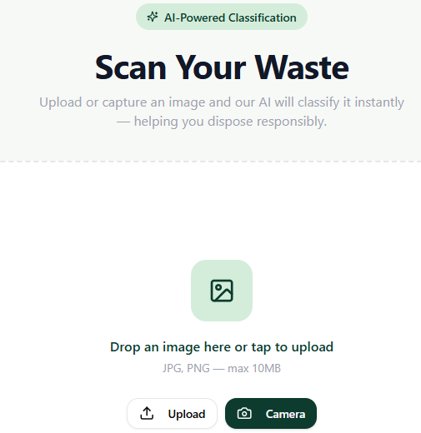
Fig. 3 —Training vs validation accuracy across epochs

Fig. 4 — AI-Based Waste Classification

CHAPTER 6: CONCLUSION
This project designed and implemented a Smart Waste Classification System that combines a CNN-based image classifier with auxiliary sensor data to automatically identify and segregate waste into biodegradable, recyclable, and non-recyclable categories. The five sub-questions identified in Chapter 2 directly shaped the design decisions described in Chapters 3 and 4: they guided the choice of a lightweight transfer-learning model for fast on-device inference, the decision to fuse sensor data with image features, the dataset size and augmentation strategy adopted, the actuator design used for segregation, and the reporting mechanism built into the monitoring dashboard.
The trained model achieved a test accuracy of approximately 92.7% across six waste categories, and the confusion matrix shows that most misclassifications occur between visually similar recyclable sub-categories (for example, metal and glass) rather than across the biodegradable/recyclable/non-recyclable boundary that matters most for correct physical segregation. The implemented dashboard successfully surfaces live classification results and bin fill-levels, supporting more efficient collection scheduling.
Overall, the results indicate that the proposed system is a practical and extensible approach to automated waste segregation. Future work includes deploying the model on embedded hardware for real-time on-device inference, expanding the dataset with more locally collected samples to improve robustness, and integrating the system with smart-city waste-collection infrastructure.

CHAPTER 7: EVALUATION RUBRIC
The following rubric was used to guide the preparation and self-evaluation of this report against its stated objectives.
Criterion | Description | Max Marks
Objectives | Clarity, relevance, and measurability of the stated project objectives. | 10
System Design | Soundness of the architecture, module decomposition, and class-level design. | 20
Implementation | Correctness, completeness, and code quality of the classification and control pipeline. | 20
Dataset Handling | Appropriateness of dataset description, preprocessing, and train/test methodology. | 15
Results & Screenshots | Clarity and correctness of presented results, screenshots, and evaluation metrics. | 10
Conclusion | Depth of reflection, honest discussion of limitations, and future scope. | 10
Documentation & Presentation | Overall report structure, formatting, and clarity of writing. | 5
CO Alignment | Output/implementation reflects the Course Outcomes: CO1 (intelligent agents & uninformed search), CO2 (Greedy Search, A*, CSP, Minimax, Alpha-Beta pruning with heuristics), CO3 (propositional logic, FOL, inference, resolution, chaining, knowledge representation), CO4 (decision tree, reinforcement learning, classification models), and CO5 (PySpark, RDD operations, intelligent agent architecture, scalable distributed AI systems). | 10

Total: 100 marks

